

**April 3, 2025**

**U.S. Coast Guard Auxiliary,**

**First District, Southern Region**

**NAVIGATION SYSTEMS**

**2025 BULLETIN**

|  |  |  |  |
| --- | --- | --- | --- |
| **This is what we are!**  **Our 2025 Mission!**   |  | | --- | | **We *verify* the Private Aids, *check* the Federal Aids, *survey* the Bridges, and *correct* the Nautical Charts of USCG First District, Southern Region. (CT, NJ, NY, VT)** |   **How we do it!**   |  | | --- | | **Prevention, Accuracy, Credibility, Timeliness, Professionalism, and Service to the United States Coast Guard.** |   **Our 2025 Annual Goals!**   |  | | --- | | **First Priority – SAFETY !**  **Second Priority – *Verify* the Private Aids which were not verified last year.**  **Third Priority – *Complete* the Photograph Project for Private Aids.**  **Fourth Priority – *Survey* the Bridges specified below.**  **Fifth Priority – *Identify and document* all “*Unauthorized*” Private Aids.**  **Sixth Priority – *Check* the remaining Private Aids in each AOR.**  **Seventh Priority – *Check* the Federal Aids in each AOR.**  **Other activities:**  ***Correct* all discrepancies observed on NOAA Charts in each AOR.** |   **ANNOUNCEMENTS**   1. **New Product**   We now have a new tool to visualize all of the aids which are in the LIGHT LIST. You select only the area which is of interest to you. This product comes with a complete user guide which I recommend that you print for future reference.  As stated, the Light List is the reference point. Many of the aids on the Priority List are CLASS 3 regulatory aids which are not contained in the LIGHT LIST and therefore are not displayed.  During inclement weather, ignore the TV and poke around this product. I think you will be impressed.  [Maritime Safety Information Products | Navigation Center](https://navcen.uscg.gov/msi)  LOCAL NOTICE TO MARINERS (LNM) APP USER GUIDE  Disclaimer: This guide is produced to assist users in effectively navigating and utilizing NAVCEN’s Local Notice to Mariners (LNM) Application, a dynamic tool that sources up-to-date data related to the Light List, discrepant federal aids, discrepant private aids, temporary changes, and marine events. The spatial reference for this application is WGS 1984. LNM data will be refreshed near the top of every hour and every fifteen minutes after. The Light List data will be refreshed every twenty-four hours at approximately 0520 EST. The updated data will provide constant accurate data to mariners, ensuring alignment with the U.S. Coast Guard's responsibility to protect the Marine Transportation System (MTS) and marine environment as outlined in 46 USC Chapter 700. This guide will help you in understanding the application’s functionality promoting optimal and efficient use.     1. **Revised PQS**   A new AV PQS handbook was released on March 28, 2024 . The full handbook follows.  [Coast_Guard_Aids_to_Navigation_Program_Handbook_16500.16_Electronic_Signature.pdf (uscgaux.info)](https://wow.uscgaux.info/Uploads_wowII/BX-GROUP/Coast_Guard_Aids_to_Navigation_Program_Handbook_16500.16_Electronic_Signature.pdf)  The revised Performance Qualification Standard (PQS) follows Chapter 3 under the heading “Enclosure 1”  In the PQS you will see reference to a “Verifying Officer (VO)”. This is the person whom we have been identifying as your MENTOR, so same function but new title.  Two new Mission Codes have been added for you to use for time entry in AUXDATA. They are:  Chart/Coast Pilot Updates (Mission Code 33)  ATON Program Training (Mission Code 34)  Chapter 2, Section C states what is included in each Code  Please report your activity promptly, both to the Coast Guard and to AUXDATA II. When you or your IS  officer enters your Navigation Systems (NS) time into AUXDATA II, please follow these standards for the  NS mission codes.  • Each Individual Activity Log for NS can have only one LEAD, and at most one TRAINEE if  applicable. Do not enter NON-LEADS or more than two people on an Activity Log.  • For mission code 30 or 31, change the OPCON to the ANT responsible for the Federal (30) or  private (31) aid.  • For mission code 32, change the OPCON to the Sector in which the bridge is located.  • For the new mission codes 33 and 34, do not change the OPCON. It will automatically be filled  in as First District Southern Region.  • If you received AUXDATA credit while on an authorized patrol, do not count that time for  mission codes 30, 31, 32, or 33. Enter only the time you spent before the patrol doing required  research and after the patrol completing the paperwork to report the aids or bridges you  checked.   1. **Harbormaster Ride Along Program (HMRAP)**   This program is one year old in First Southern but is several years old in First Northern. This program is perfect for AV’s who have several year’s experience and are looking for a ride.  Since this program is new, contact your ADSO-NS.  Chris Howe – ADSO-NS ANT LIS  (Long Island Sound - East of Rye, NY)  David Belding – ADSO-NS ANT Moriches  (South Shore of Long Island and the Bays)  Alan Nye – ADSO-NS ANT Burlington  (Vermont and NY - South to Whitehall, NY)  Art Kramer             – ADSO-NS Sec NY  (combines ANT NY and ANT Saugerties)  (NY South of Whitehall, NY & NJ)   1. **Currency Maintenance in D1SR**   Requirements have changed effective January 2025.  See “Currency Maintenance” listed below |
|  |

**++++++++++++++++++++++++++++++++++++++++++++++++++++**

**OVERVIEW**

The reason for this bulletin is to present the ‘big picture’ and to encourage the use of AUXDATA. This is the repository of combined statistics that is available to all Auxiliarists. The following listing is an extract based on information that you submitted to your IS Officers. Bottom line, please submit the data so that you receive proper credit.

**PATON verification**

District One Southern Region (D1SR) consists of USCG Sector NY, Sector LIS and a portion of Sector Northern New England (NNE). This area contains 2,549 Private Aids (PATON). Each year the Sectors must verify one third of the aids in their area. This is in addition to all of their Federal Aids and numerous other assignments. Due to the area covered, the large number of aids and limited resources, the CG has assigned the Auxiliary to assist. This takes a large burden off the Active Duty side, but it does not relieve the Active Duty from completing the assignment.

Since lighted aids must be verified at night, it is suggested that these aids are verified during the day and, where possible, the lights are observed at night from shore. This should reduce the number of night patrols.

The distribution of PATONs within the Divisions of D1SR is highly variable. Because of this, verifying aids in one area can be easy but difficult in another.

To assist you in selecting which aids require verification, all aids are grouped into 40 Patrol Areas. There are 22 areas within Sector NY, 14 for Sector LIS and 5 for Station Burlington. For those who would like a visual presentation, you can view the Navigation Systems web site at: <http://uscgaux1sr-aton.org/Paton.htm> On this screen, click on “PATROL AREAS with maps”.

The southern boundary of ANT Saugerties is at the Bear Mountain Bridge (BMB). All Hudson River aids, south of this line, are in the New York database. Aids north of the BMB are in the Saugerties database. This line does not conform to any Division boundary.

Being ready to verify PATONS means being ready to get underway, so please remind AVs that are also Crew qualified, to make sure that their PPE is in order.  This includes making sure EPIRB battery and registration are in order, that the PML is working properly, that all PPE equipment is correctly attached to their SAR vest and that it has been inspected as per their Flotilla's procedure.

AV candidates and AVs that are not Crew qualified, should request an Auxiliary PFD through their leadership chain.

The PFD must contain a Personal Locator Beacon (PLB), Whistle and Mirror.

Similarly, their "tools of the trade" should also be checked for good working order and accuracy. GPS units should be checked against known locations or other GPS units.  Depth sounders can be checked against lead lines.  If any equipment has been changed since last used, the "accuracy statement" for the 7054 must be updated.

**BRIDGE inspection**

Since 1996, the USCG has relied on the Auxiliary to observe and report discrepancies on bridges over navigable waterways. Verifiers will concentrate on Movable bridges which contain Lights

It should be noted that many of these bridges can be observed from land. Hence they can be verified at your convenience. However, before you proceed, contact one of your Flotilla officers as specified below in the paragraph “SAFETY first.

The Bridge database is maintained in an Excel Spreadsheet. Contact the ADSO for Bridges David Marriott ([wdavidmarriott@gmail.com](mailto:wdavidmarriott@gmail.com)) for bridge details and the current procedure for reporting all bridge work.

Since rivers are frequently the dividing line between Divisions, some Bridges are in two Divisions.

You will notice that Division 11 does not have an AV but they do have 11 listed bridges. Please verify these bridges, no approval needed. By the way, one of these is a retractable bridge built in the 1800’s. It is the only one in D1SR and is quite unique.

For those with GOOGLE access, the following hyperlink will display a map of the bridges in D1SR. The map also outlines the CG Sectors and the general area of each Auxiliary Division. Divisions do not have hard boundaries specified. Shown are the parameters used for the assignment of PATON and Bridge Divisions verified by D1SR Aid Verifiers.

<https://www.google.com/maps/d/edit?mid=1qrC4y00iYC5Lt7Khgat_mkjvF9PilUs&usp=sharing>

HINT: Select the entire line (highlight) then “Ctrl + Click to follow the link”

Unlike PATONs where we only have a couple of months to inspect them, bridges can be inspected year round. If you are interested in inspecting bridges, grab another Aux member (doesn't have to be AV qualified), go to the Google Map that shows all the bridges and go inspect a bridge(s).

For your information there are 291 bridges located in our District's AOR, only 31 of them have been inspected.

PATON and Bridge inspections is one of just a few missions that is directly helping the Coast Guard do its required job.  If we don't do these missions, the CG has the responsibility to do them.

**Bridge Reporting 2025**

We are not going to make any significant changes to the bridge program at this time.

The CG’s First District Bridge Department has a new Commander, Mr. Greg Hitchen, who has taken over from Ms. Donna Fisher. For those who may not know, the First District Bridge Department and the DIRAUX 1SR are located in the same CG building at the Battery in NYC.

The CG is in the process of redesignating each of the bridges, giving them each a new ID. We will provide additional information on this as we receive it. For now, we will continue to use our AUX numbering system and the waterway to designate each of the bridges.

**Bridge priorities for 2025:**

1. Lighted bridges that open to allow traffic through, with any normal navigation activities upstream of the bridge.

2. Fixed bridges with lights, with any normal navigation activities upstream of the bridge.

3. All others.

As with any navigation aid, if a discrepancy is significant enough to have the potential to cause damage to property or life, it should be reported to your Sector Command immediately.

Report all observations to the ADSO-NS-Bridges using the Excell 7055 fillable form found on the NS website.

The references in the Bridge section of our NS website will be updated with revised documents.

**CHART updating**

For AVs or other members interested in training to report chart updates to NOAA, there is a lot of good information available online on a) the National Navigation Systems website, and b) the AUX-06 C-school website under "Required Materials." D1SR training may be offered if there is enough interest.

**SAFETY first**

Accidents happen at the most inopportune moments. You can be in very serious trouble if you are alone. This is especially true at night. Boat patrols are under written orders and automatically require at least two people. Use the same rational for ALL missions, not just missions for which written orders have been issued. Within NS, the missions are PATON, Bridge and Chart.

Contact at least one of your Flotilla officers, who you trust to cover your back, stating your planned mission location, date and time (aka float plan). At the completion of the mission, or the specified time, report back to this person. If you don’t report back, this officer is expected to initiate a search. Notification should be done by email, text or voice. Email and text are better since you will have a record if it should ever be needed. Again, this contact is your lifeline. This procedure is similar to VE

Consider having a partner on the mission. Besides safety, this provides a training opportunity. There are tricks to every trade. Don’t hoard your techniques.

**PFD Reminder**

Just a reminder that anyone performing a mission on or near the water (e.g., NS from a facility) must be in appropriate PFD (Personal Flotation Device).  It is up to the member to perform each and every mission as safely as is possible.

Note that NS verifiers on a vessel underway are required to wear an Aux PFD.  They are NOT crew (unless qualified and appointed as crew for that mission), and as such are not required to wear SAR vests and related equipment.  Should the facility be required to respond to a mission, the NS verifier will maintain a position so as to not obstruct the crew from performing their assigned duties.

Many flotillas and divisions currently have in their possession extra PFDs.  At a minimum, each division has a PFD Maintenance officer, who keeps records of issued equipment and inspections.  Members should canvas their respective flotillas and division PFD Maintenance officer for appropriate gear requests and issuance.  After this process, should a member still need a PFD, a request should be made thru the DSO-NS.

As member safety was, is and will continue to be our top priority, please spread the word far and wide!

Currency Maintenance in D1SR

National requirements for currency maintenance by Auxiliary Aid Verifiers became effective January 2025 as specified in Chapter 2 Section C of the new ATON Handbook (16500.16) . [Coast_Guard_Aids_to_Navigation_Program_Handbook_16500.16_Electronic_Signature.pdf (uscgaux.info)](https://wow.uscgaux.info/Uploads_wowII/BX-GROUP/Coast_Guard_Aids_to_Navigation_Program_Handbook_16500.16_Electronic_Signature.pdf)

Exception: D1SR has implemented District-specific requirements. Chapter 2 Section A.5. Verifications. This paragraph is in conflict with D1 SOP. The active duty Coast Guard must verify all CLASS 1 aids annually. CLASS 1 verification is not an Auxiliary function. These aids are on the priority list and assigned to the CG.

Since “Currency” is based on AUXDATA, please make sure that you report all of your activity to your IS officer.

Aid Verifiers are able to perform all Navigation Systems missions in D1SR. They have access to the ‘U.S. Harbormaster Private Aids to Navigation’ database maintained by U.S. Coast Guard First District. They are able to report Annual Bridge Surveys to the D1SR ADSO-NS who communicates with the CG Bridge office.

**NOTICE**  To provide Navigation Systems with all of the credit it deserves, we would like to know which members are actually involved. This has to be done by the coxswain when completing the Order Management. The portion of the patrol involving NS should be entered as **Mission 03 (Navigation Systems Patrol)**. As the AV on board, please request that code 03 is entered on the 7030.

Every AV should have Harbormaster access. Contact your ADSO-NS for access requirements.

|  |  |  |  |  |
| --- | --- | --- | --- | --- |
|  |  |  |  |  |
|  | **STATISTICS** | **2025** |  |  |
|  | **Aid Verifiers (AV)** | **84** |  |  |
|  | **Harbormaster Access (HM)** | **67** |  |  |
|  | **Verifying Officers (VO)** | **12** |  |  |

This **Citation** has my name on it but it actually belongs to each of you. This job is performed as a **TEAM**.

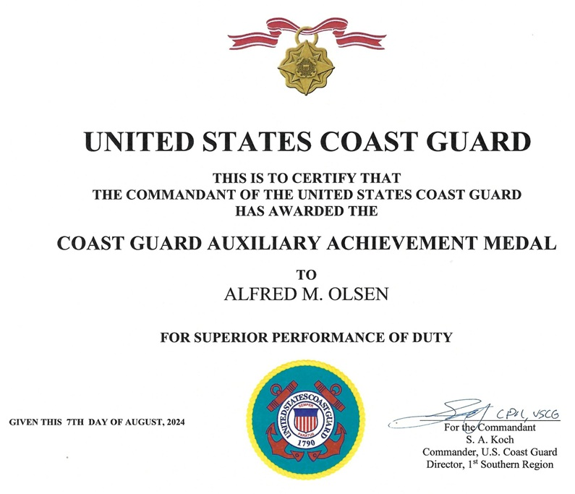

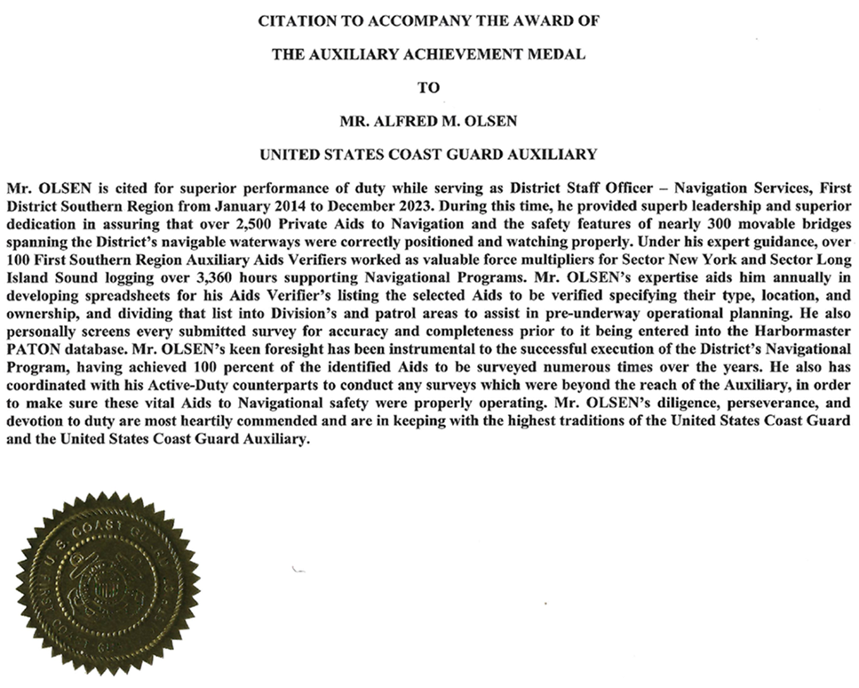

**Thank you**

Again, I want to thank all those who have, and/or plan to, contribute to the success of the NS program

|  |
| --- |
| **IMPORTANT:** It is part of DSO-NS’s function to assure the Coast Guard, that any Auxiliarist who verifies and submits a 7054 PATON Report on-line to the Harbormaster System, is qualified as an AV and is current (has submitted two or more ATON, PATON, or Bridge verification or check reports each year. I try to do everything in my power to insure that AVs do not lose their AV currency and/or their AV qualification. However, there are legal implications for the Coast Guard if this protocol is not followed. Your AV qualification is potential evidence that can be introduced in court that you were trained and qualified when you performed this important work for the Coast Guard.  ***Please! No begging or whining***. Be sure that you correctly update **AUXDATA** with your **Navigation Systems activity.**  ***If you need assistance, feel free to contact me directly.*** |

**ACTIVITY CALENDAR for Navigation Systems Staff Officers**

|  |
| --- |
| If you are relieving an NS Staff Officer at any level, you should have received all the records and materials for your new office by now. If not, make arrangements with your predecessor and get the records transferred to you as soon as possible.  Secure a copy of the list of the current Staff Officers for your AOR in the Navigation Systems Program. Remind them to check their E-mail address in AUXDATA. Have them send any corrections to your SO-IS.  Start working on your ***Navigation System Program Plan***. If you have a problem, contact your SO-NS, ADSO-NS, or DSO-NS for assistance. Each NS Program should include:   * + - **Private Aid** (PATON) ***Verification*** **Program**, Only Current AV-qualified volunteers may participate.     - **Private Aid (**PATON) ***Checking* Program**. Only Current AV-qualified volunteers may participate.     - **Private Aid Photo Program.** All Auxiliary volunteers may participate.     - **Bridge** (BAP) **Surveying Program**. Only Current AV-qualified volunteers may participate.     - **Bridge** (BAP) **Checking Program**. All Auxiliary volunteers may participate.     - **Federal Aid** (ATON) ***Checking* Program**. All Auxiliary volunteers may participate.     - **Chart-Updating Program**. All Auxiliary volunteers may participate. |

**Please forward this bulletin to your members at the Flotilla and Division levels. We have important Coast Guard business to complete each year and we need AV and NS Staff Officer support from skilled and trained Auxiliarists in every Division of First Southern in order to meet our goals.**

*Under the Privacy Act of 1974, all information in this bulletin may only be used for official purposes. Any other use is a violation of law. This bulletin was prepared and published by the First Southern Navigation Systems Team. Contact the editor at* [***aolsen413@gmail.com***](mailto:aolsen413@gmail.com)